CREATE REGISTRATION INTERFACE

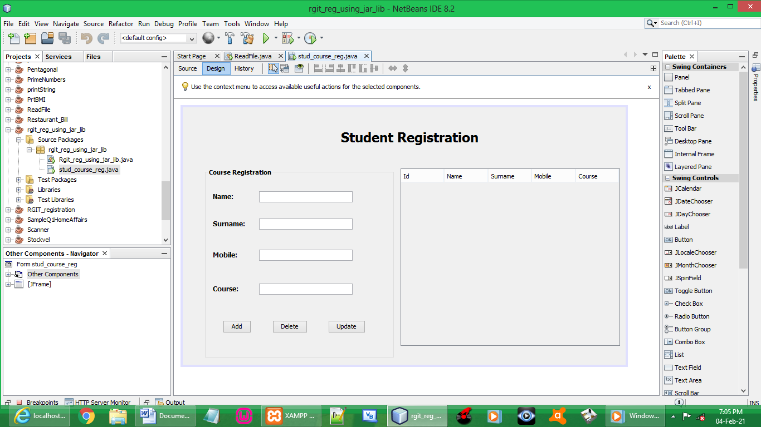

CODES:

import java.sql.Connection;
import java.sql.DriverManager;
import java.sql.PreparedStatement;
import java.sql.ResultSet;
import java.sql.ResultSetMetaData;
import java.sql.SQLException;
import java.util.Vector;
import java.util.logging.Level;
import java.util.logging.Logger;
import javax.swing.JOptionPane;
import javax.swing.table.DefaultTableModel;

public stud_course_reg() {
initComponents();
table_update(); // to make jtable details appear from database
}

Connection conn;
PreparedStatement pst;

BUTTON ADD:

// Storing entered input by user
String name = txtName.getText();
String surname = txtSurname.getText();
String mobile = txtMobile.getText();
String course = txtCourse.getText();

try {

conn = DriverManager.getConnection("jdbc:mysql://localhost/rgi","root","");

pst = conn.prepareStatement("insert into it(name, surname, mobile, course) values(?,?,?,?)");
pst.setString(1, name);
pst.setString(2, surname);
pst.setString(3, mobile);
pst.setString(4, course);
pst.executeUpdate();

JOptionPane.showMessageDialog(this, "Add Completed");

table_update();

txtName.setText("");
txtSurname.setText("");
txtMobile.setText("");
txtCourse.setText("");

} catch (SQLException ex) {
Logger.getLogger(stud_course_reg.class.getName()).log(Level.SEVERE, null, ex);
}

BUTTON DELETE

DefaultTableModel df = (DefaultTableModel)jTable1.getModel();
int selectedIndex = jTable1.getSelectedRow();

try {

int id = Integer.parseInt(df.getValueAt(selectedIndex, 0).toString());

int dialogResult = JOptionPane.showConfirmDialog(null,
"Are you sure you want to delete the data?", "Warning",JOptionPane.YES_NO_OPTION);

if (dialogResult == JOptionPane.YES_OPTION){

String name = txtName.getText();
String surname = txtSurname.getText();
String mobile = txtMobile.getText();
String course = txtCourse.getText();

conn = DriverManager.getConnection("jdbc:mysql://localhost/rgi","root","");

pst = conn.prepareStatement("delete from it where id = ?");
pst.setInt(1, id);

pst.executeUpdate();

JOptionPane.showMessageDialog(this, "Delete Completed");

table_update();

txtName.setText("");
txtSurname.setText("");
txtMobile.setText("");
txtCourse.setText("");

}
} catch (SQLException ex) {
Logger.getLogger(stud_course_reg.class.getName()).log(Level.SEVERE, null, ex);
}

BUTTON UPDATE

DefaultTableModel df = (DefaultTableModel)jTable1.getModel();
int selectedIndex = jTable1.getSelectedRow();

try {

int id = Integer.parseInt(df.getValueAt(selectedIndex, 0).toString());
String name = txtName.getText();
String surname = txtSurname.getText();
String mobile = txtMobile.getText();
String course = txtCourse.getText();

conn = DriverManager.getConnection("jdbc:mysql://localhost/rgi","root","");

pst = conn.prepareStatement("update it set name = ?, surname = ?, mobile = ?, course = ? where id = ?");
pst.setString(1, name);
pst.setString(2, surname);
pst.setString(3, mobile);
pst.setString(4, course);
pst.setInt(5, id);
pst.executeUpdate();

JOptionPane.showMessageDialog(this, "Update Completed");

table_update();

txtName.setText("");
txtSurname.setText("");
txtMobile.setText("");
txtCourse.setText("");

} catch (SQLException ex) {
Logger.getLogger(stud_course_reg.class.getName()).log(Level.SEVERE, null, ex);
}

JTABLE FUNCTION (data at database to appear on Jtable):

private void table_update(){

int x;

try {

conn = DriverManager.getConnection("jdbc:mysql://localhost/rgi","root","");

pst = conn.prepareStatement("select * from it");
ResultSet rs = pst.executeQuery();
ResultSetMetaData rss = rs.getMetaData();
x = rss.getColumnCount();

DefaultTableModel df = (DefaultTableModel)jTable1.getModel();
df.setRowCount(0);

while(rs.next()){
Vector v = new Vector();

for(int a = 1; a <= x; a++){
v.add(rs.getString("id"));
v.add(rs.getString("name"));
v.add(rs.getString("surname"));
v.add(rs.getString("mobile"));
v.add(rs.getString("course"));
}

df.addRow(v);
}
} catch (SQLException ex) {
Logger.getLogger(stud_course_reg.class.getName()).log(Level.SEVERE, null, ex);
}

JTABLE FUNTION (event, mouse, mouseClick):

DefaultTableModel df = (DefaultTableModel)jTable1.getModel();
int selectedIndex = jTable1.getSelectedRow();

txtName.setText(df.getValueAt(selectedIndex, 1).toString());
txtSurname.setText(df.getValueAt(selectedIndex, 2).toString());
txtMobile.setText(df.getValueAt(selectedIndex, 3).toString());
txtCourse.setText(df.getValueAt(selectedIndex, 4).toString());
OUTPUT:

RUN STUDENT REGISTRATION

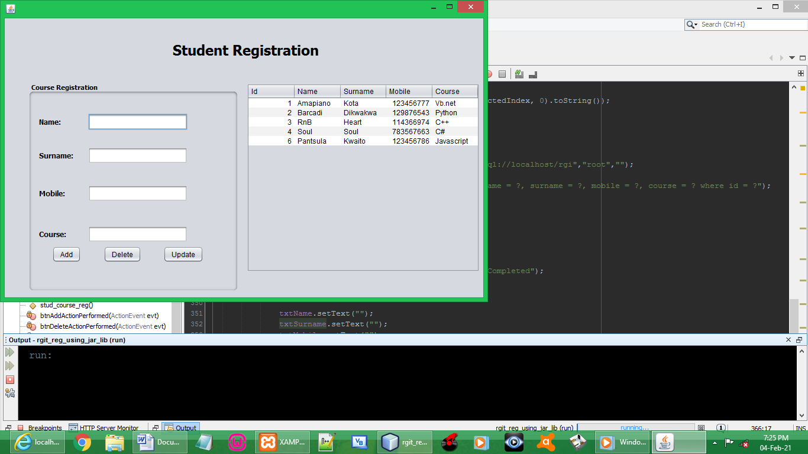

ADD DETAILS

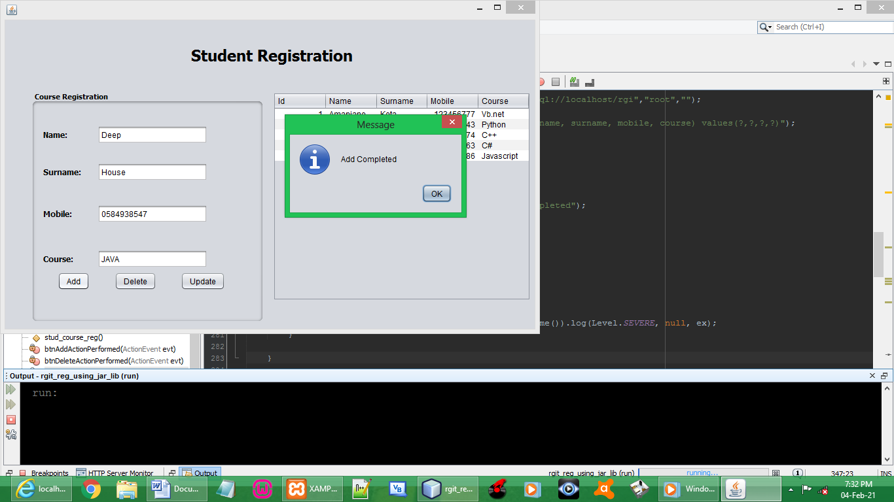

THE ADDED DETAILS

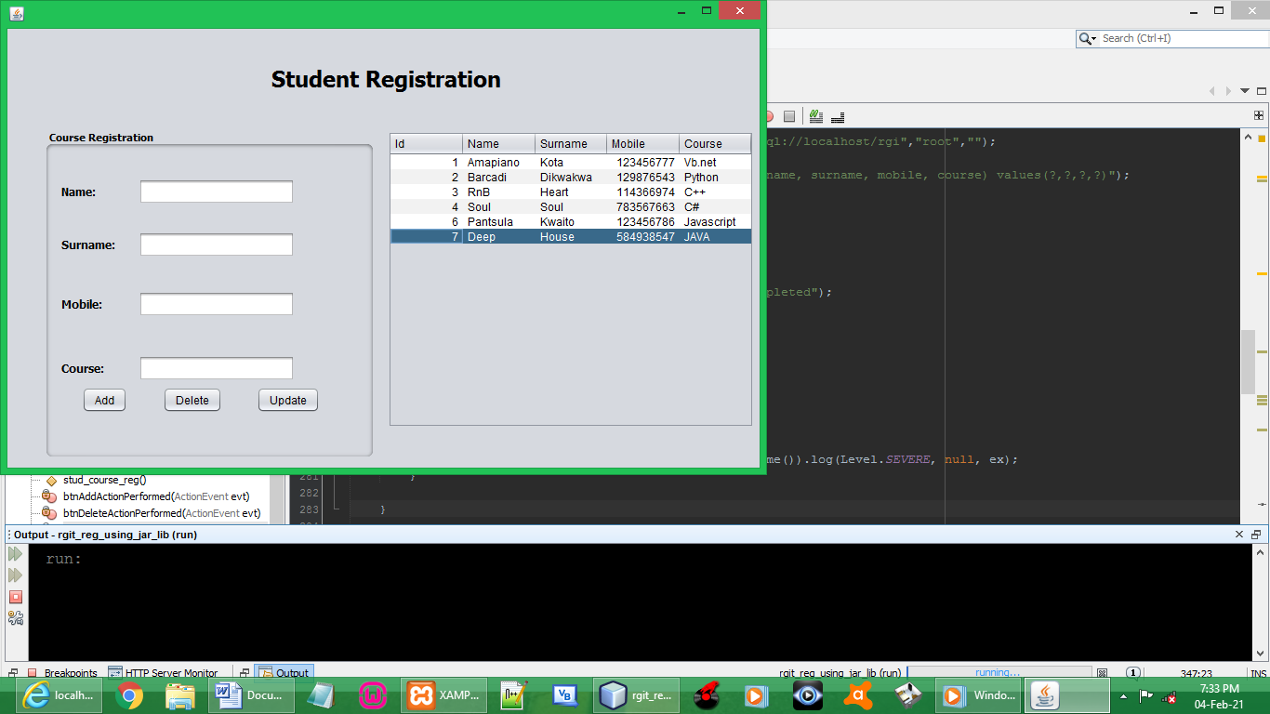

UPDATE THE DETAILS

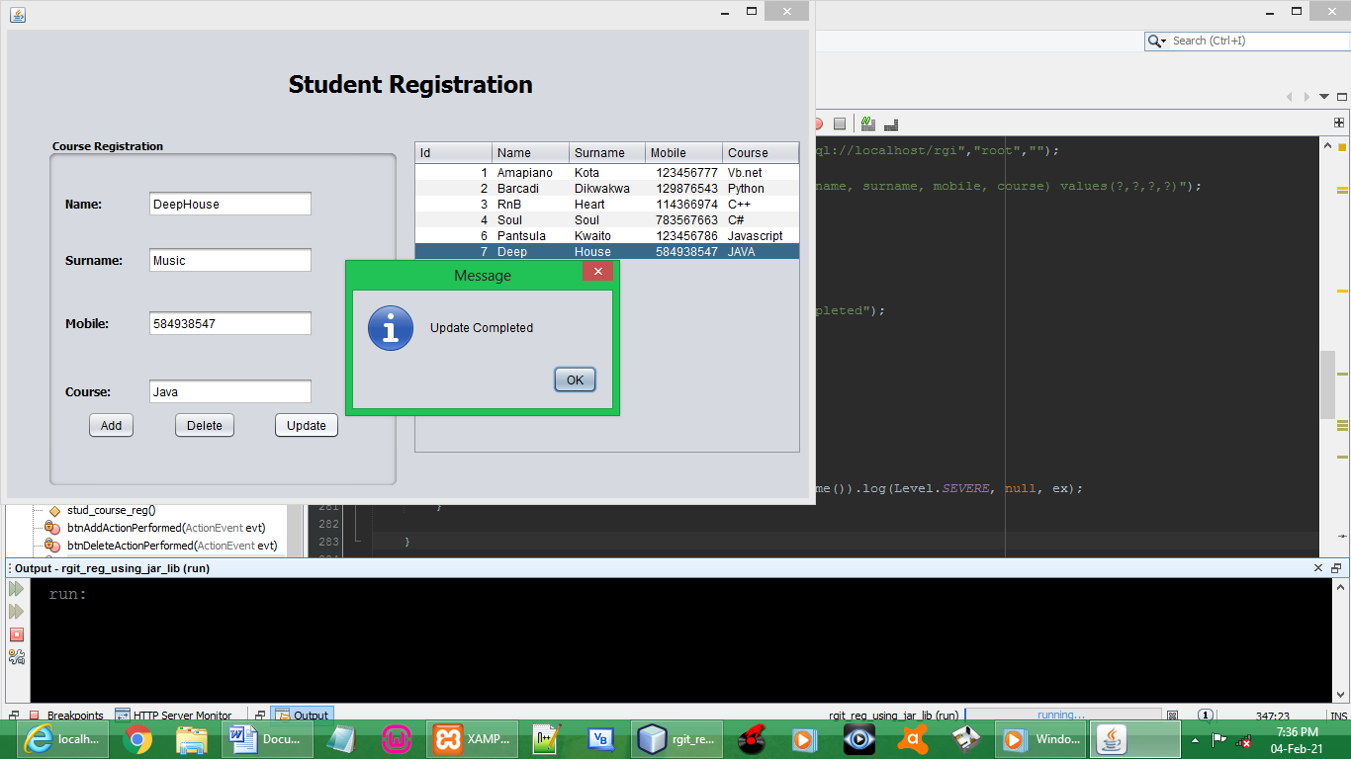

THE UPDATED DETAILS

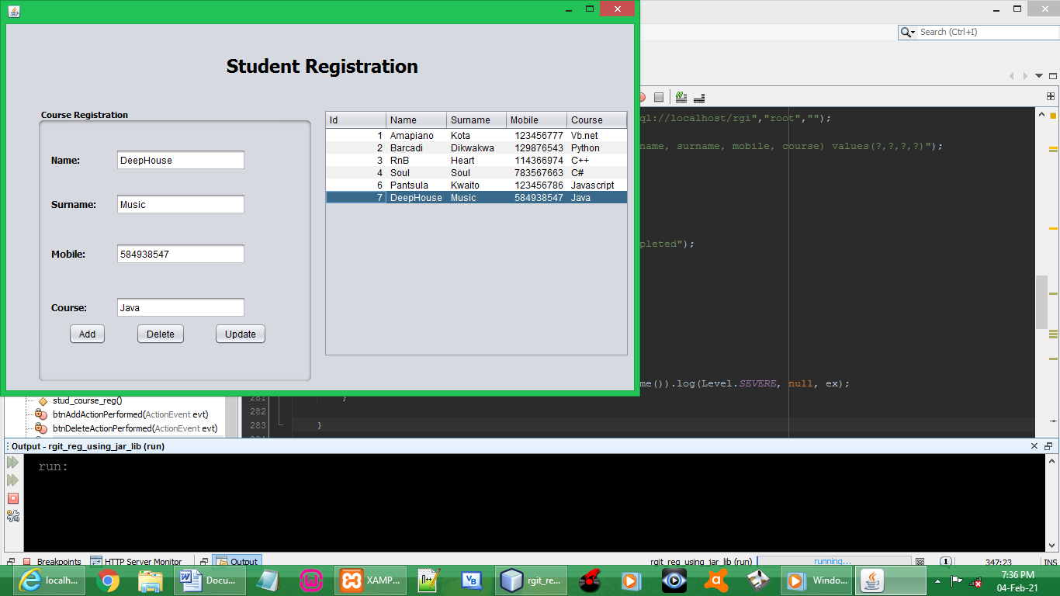

DELETE THE ADDED DETAILS

